



**CS6P05 Project**

**5% FYP Proposal**

**Final Year Project Proposal**

**2023 Autumn**

**Project Title:** AgroMart – Enabling Farming products online

**Submitted by: Supervised by:**

**Student Name:** Sanikant Kushwaha **External Supervisor:** Shekhar Timsina

**London Met ID:** 22015764 **Internal Supervisor:** Bishal G.C.

**College ID:** NP01CP4S220119

**Assignment Due Date:** 29 Nov 2023

**Assignment Submission Date:** 28 Nov 2023

*I confirm that I understand my coursework needs to be submitted online via Google Classroom under the relevant module page before the deadline in order for my assignment to be accepted and marked. I am fully aware that late submissions will be treated as non-submission and a mark of zero will be awarded.*

**Table of Contents:**

1. INTRODUCTION: 1

i. Problem Scenario: 1

ii. The Project as a solution: 1

2. AIMS and OBJECTIVES: 2

i. Aims: 2

ii. Objectives: 2

3. EXPECTED OUTCOMES AND DELIVERABLES: 3

4. PROJECTS RISKS, THREAT AND CONTINGENCY PLANS: 4

5. METHODOLOGY: 5

i. Prototype Methodology: 5

6. RESOURCE REQUIREMENTS: 7

i. Software Requirement are: 7

ii. Hardware Requirement: 7

7. WORK BREAKDOWN STRUCTURE: 8

8. MILESTONES: 9

9. PROJECT GANTT CHART: 10

10. CONCLUSION: 12

11. References 13

**Table of Figure:**

Figure 1: Prototype Methodology 6

Figure 2: Work Breakdown Structure 8

Figure 3: Milestone 9

Figure 4: Gantt Chart 10

# INTRODUCTION:

AgroMart is an online platform designed to serve specifically to the agricultural community. The platform aims to provide farmers with easy access to wide range of agricultural products, including pesticides, fertilizers, seeds, spray machines, agricultural tools, and various agricultural products specialized to their needs.

## Problem Scenario:

The main problem for the farmers is to get the agricultural product on time. Farmer in remote areas face challenges accessing agricultural supplies. Farmer struggle to access accurate and timely information about the latest products, best practices and innovative agricultural tools. Local physical stores may have a limited range of products, restricting farmers choice. Farmers may not be aware of the best-suited products for their specific needs as well they are not getting the seasonal products on time for which they struggle to find seasonal specific products. (Mishra, 2023)

## The Project as a solution:

This platform facilitates access to fertilizers, pesticides, seeds and agricultural tools, ensuring that farmers in remote area can easily get essential supplies. This platform provides the tips and advice. The platform streamlines the ordering process with features like product listings, cart functionality, and order tracking. This platform also uses to show the recommended product according to the customer.

# AIMS and OBJECTIVES:

## **Aims:**

The main aims of this project are to solve the problems of Farmers by providing agricultural products in wide range including pesticides, fertilizers, seeds, spray machines, agricultural tools, and various agricultural products specialized to their needs.

## Objectives:

The objectives of the projects are:

* To provide a wide range of agricultural products.
* To address and solve the challenges faced by the farmers while buying agricultural products.
* To support and enhance agriculture practices by providing farming resources and tools.
* User-friendly online platform for easy product browsing and ordering.
* Offering products to meet the unique need of local farming community.

# EXPECTED OUTCOMES AND DELIVERABLES:

The expected outcomes and deliverables of the project is WebApp for the Admin and Mobile App for the customer. Where the customer can operate multiples of the function through the Mobile App.

Expected outcomes in WebApp for the admin role are:

* Admin can register and manage profiles like they can edit details, change password.
* In the Admin Dashboard, Admin look for the total users, and products for in-stock and out-stock products.
* Admin manage the account.
* Admin add products, delete, and update products details.
* Admin manage the orders and transaction.
* Admin see the products rating.

Expected outcomes in Mobile App for Customer role are:

* Customers can navigate through app, register and login to the app.
* Customers look for the products and if want to buy products they can simply add products to the cart and checkout the products for product ordering.
* Customer can see their ordered products in the Product order page.
* Customer can also navigate through product description page where they see the product details like product status, product price, etc. and can give rating and review for the products.
* When customer navigate for product description page, they see the similar type of products on the product description page.
* Customer also look for the seasonal products.
* For easy access of product, they can search and filter the products.
* When customer checkout for the product ordering they have to pay for it to order the products.

# PROJECTS RISKS, THREAT AND CONTINGENCY PLANS:

Project risks is an uncertain event that can impact in the project either in positively or negatively whereas Negative risks are threats and positive risks are opportunities. Some risks as threat while developing this project are:

* The major risk is system crash.
* This is my first Mobile app-based project so I am feeling lots of trouble.
* As I’m using the Prototype Methodology so it cost will go higher in case of time and development.
* Difficulties in collecting the agricultural products data.
* Difficulties in learning the platform for Mobile App Development.
* While implementing Payment Integration in system for online pay.

Contingency plans mean the action and design to handle the risks and result for backup plan. Some Contingency Plans to handle the above risks are:

* Keep back-up of the project report on drive and project development on GitHub.
* Research in-depth about the mobile app development and be familiar with it.
* Search the client to gather data.
* Complete the project on time to minimize the cost.

# METHODOLOGY:

## Prototype Methodology:

Prototyping Model is a software development methodology that involves creating an initial prototype of the software product before developing the final product. Working methodology of prototype is that the system is created early in the development phase.

When the customers are unsure about the precise project requirements in progress, Project Manager employ this model of thinking. In this model, an initial prototype of the finished product is created, tested, and constantly improved based on consumer feedback until an ideal final prototype is established, which serves as the foundation for creating the finished product.

The Software Development Life Cycle & Development Phase of prototype methodology are:

* **Requirement gathering and Analysis:** This is the initial stage in designing a prototype model.
* **Quick Design:** The second phase in the prototype methodology is designing. A brief overview can be easily mentioned in this quick fundamental design.
* **Building a Prototype:** This step work for building an actual prototype from the knowledge gained from the design part.
* **Customer Evolution:** The performance model is investigated, and the client discloses the pros and cons of the design that was sent to the developer for the development process.
* **Review and Refine:** If the users provide any feedback, it will be used to improve the client's reaction on an idea, and the final system will then be accepted.
* **Development:** Developer work for the development according to the provided idea.
* **Testing:** This process is carried out to determine whether or not the program met the client's requirements.
* **Release or Deploy:** The software must be then deployed if the development satisfies the client's needs.

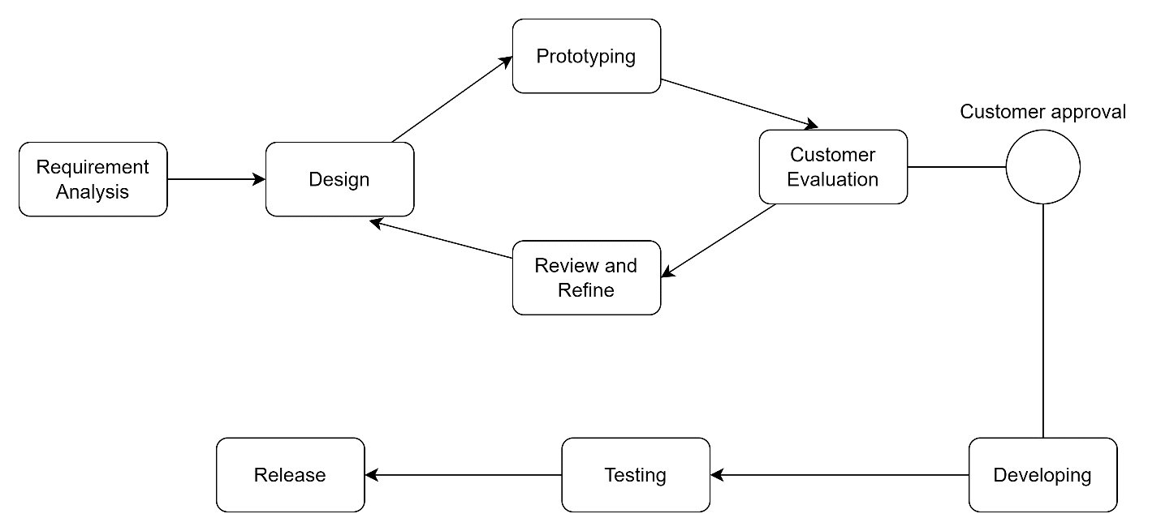

Figure 1: Prototype Methodology

# RESOURCE REQUIREMENTS:

Developing AgroMart project requires careful consideration of various resources requirement.

## Software Requirement are:

* **MongoDB:** MongoDB store structured or unstructured data. A horizontal scale-out design was implemented to create the free document database MongoDB, which uses a flexible schema to store data.
* **React.js and React Native:** React.js is a front-end JavaScript library uses for building the UI Components. Where as React Native is used to build the both iOS and Android device Applications.
* **Node.js with Express:** Node.js is an open-source, cross-platform of JavaScript runtime environment. Where as Express is a Flexible Node.js web application Framework that provides a robust set of features for web and mobile applications.
* **HTML5, CSS3, and Bootstrap:** Application panel design.
* **Microsoft word:** Used for reports documentations.
* **MS Excel:** Uses to make Gantt Chart.
* **Draw.io:** Uses for making of diagram and structures.
* **Gantt Project:** A software used for making Gantt chart.

## Hardware Requirement:

* **PC:** PC is a microcomputer, it is a most prior device used for building the whole project report, coding, etc.

# WORK BREAKDOWN STRUCTURE:

A work breakdown structure (WBS) is a visual, hierarchical, deliverable-oriented project teardown. It is a useful diagram for project directors since it allows them to break down their project scope and visualize all of the tasks required to finish their projects.

The work breakdown structure chart enables it a vital project planning tool. The highest-level project deliverable, as well as the projects and work packages that are connected with it, stand on top of the WBS diagram, while the different sections of the WBS above break down, the project scope to represent the tasks, deliverables, and work packages required to complete the project from beginning to end.

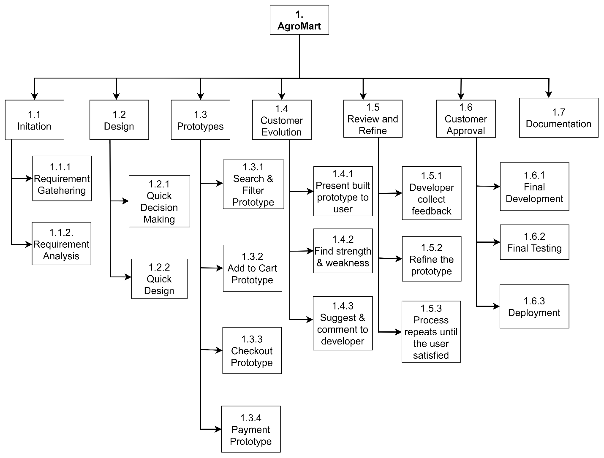

Figure 2: Work Breakdown Structure

# MILESTONES:

A design process should be the first step in every web design job. Having a design process in place and setting up the website design milestones and timeframe before begin. Milestone will help to overcome any uncertainty and distractions along the way.

A great website involves extensive research, planning, and background work to stand out. The web design process comprises several components that can be divided into simple, manageable phases, ranging from information collecting to content creation and site maintenance.

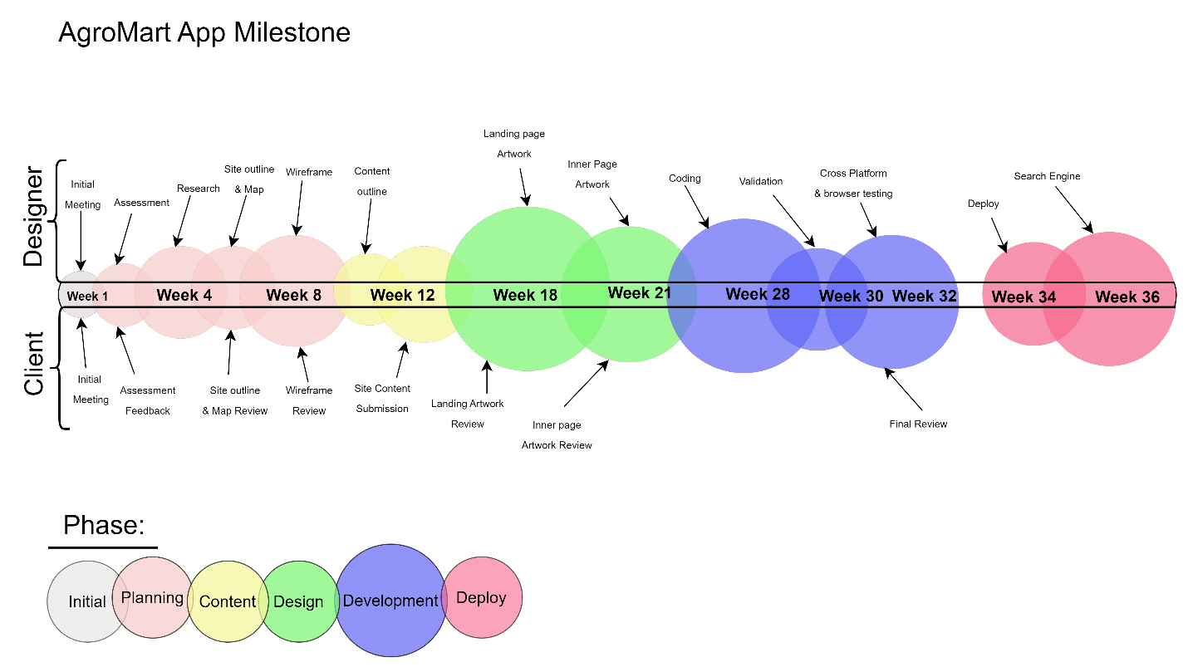

Figure 3: Milestone

# PROJECT GANTT CHART:

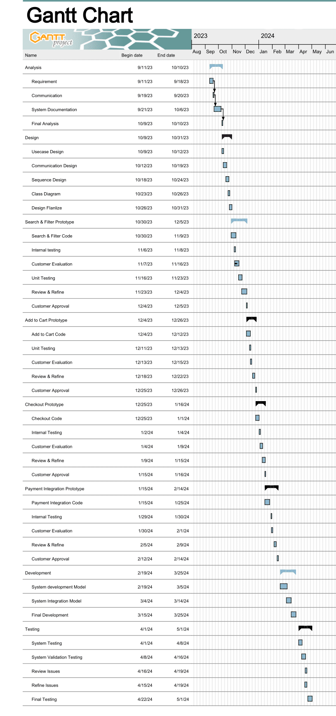

Figure 4: Gantt Chart

A Gantt chart is frequently used in project management, which is one of the most well-liked and practical ways to represent activities (tasks or events) against time. A list of the activities is located on the chart's left side, and a suitable time scale is located along the top. A bar is used to symbolize each activity, and the position and length of the bar correspond to the activity's beginning, middle, and finish dates.

# CONCLUSION:

The project is to design a Mobile Application for AgroMart Online which provides the features for the customer. Where the customer can buy the AgroMart Products for farming, as well they see similar product of same type. Customer can search and filter the products. Customer have to pay online for their ordered products.

As well as Web App will be design for the admin, where Admin can have full access to look for the customers, add products, delete products as well as users, etc. features are for the admin.

The difficulties that I should tackles is to collect data’s, enhance coding format, integrate online payment system, etc. these are the main features in my AgroMart project.

Finally, the AgroMart project for Admin and Customer will design and must meet all the required features for admin and customer.

# References

Grant, M., Khartit, K. & Kazel, M., 2022. *Investopedia.* [Online]   
Available at: https://www.investopedia.com/terms/g/gantt-chart.asp  
[Accessed 11 November 2023].

I. E. T., 2022. *Prototype Model,* s.l.: Indeed.

Lewis, S., 2023. *TechTarget.* [Online]   
Available at: https://www.techtarget.com/searchcio/definition/Prototyping-Model  
[Accessed 9 November 2023].

Mishra, K., 2023. *Agromart - The market for Farmer.* [Online]   
Available at: https://nepaleconomicforum.org/impediments-in-the-agriculture-sector-of-nepal/  
[Accessed 07 November 2023].

T. A., 2022. *asana.* [Online]   
Available at: https://asana.com/resources/milestone-chart  
[Accessed 10 November 2023].

Watts, R., 2022. *Forbes Advisor.* [Online]   
Available at: https://www.forbes.com/advisor/business/what-is-work-breakdown-structure/  
[Accessed 9 November 2023].